**Credit card lead prediction approach**

1. Performed EDA on the dataset.

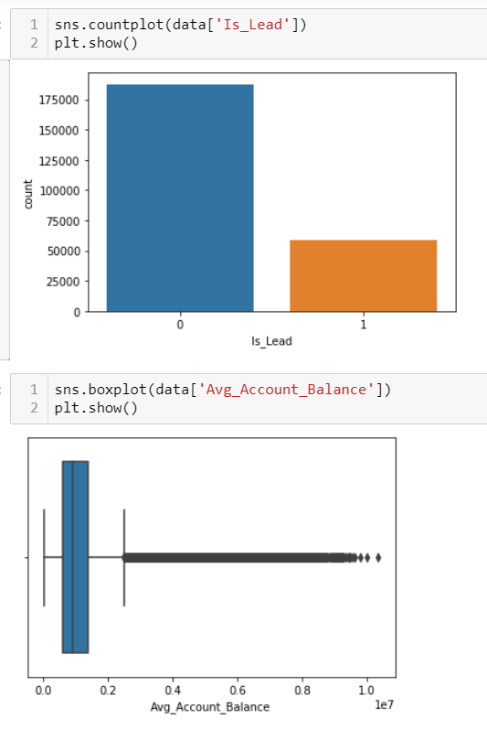

1. Performed Log transformation on the ‘Age’ and ‘Avg_Account_Balance’ features.

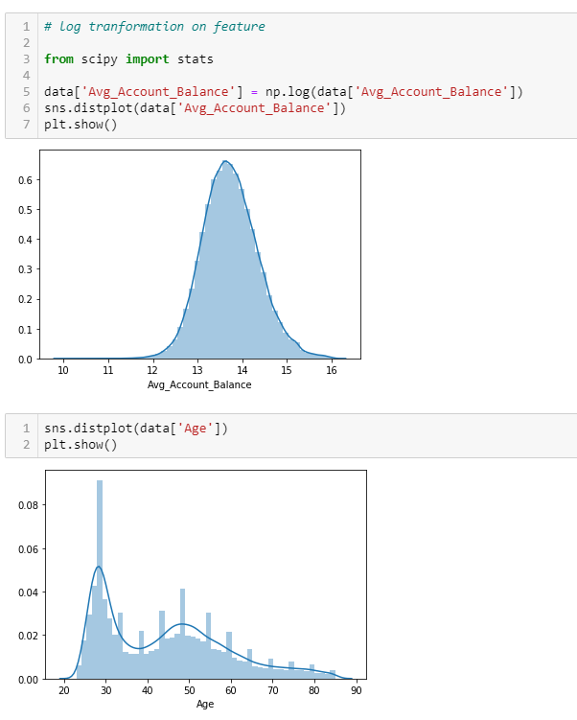

1. Replaced the Null values in the ‘Credit_Product’ feature with ‘Unknown’.

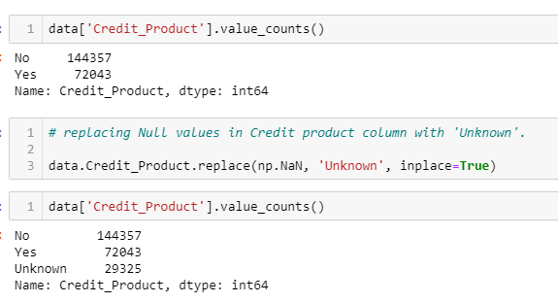

1. Converted categorical values into numerical values and dropped unwanted features.

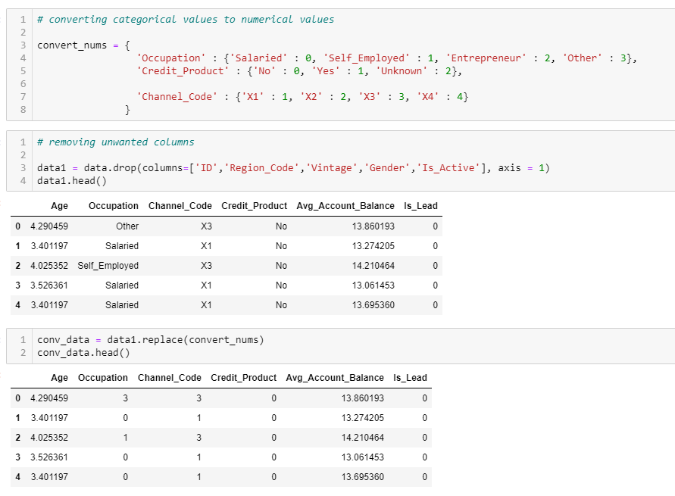

1. Implemented SMOTE technique to balance the imbalanced features.

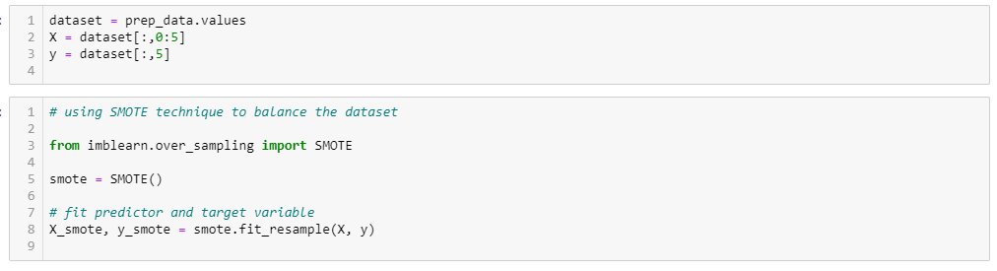

1. Applied the XGBoost classifier model as it gave the best results among other models.

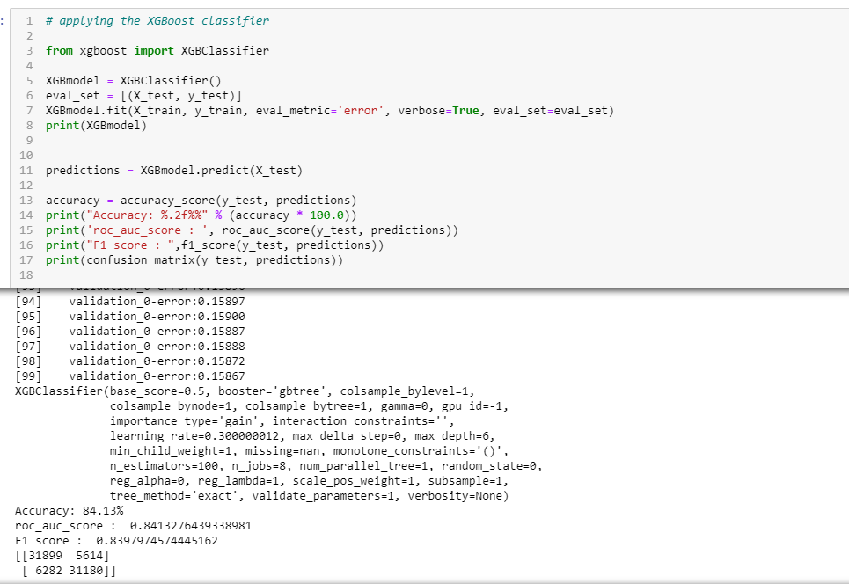

1. Imported the test dataset, pre-processed the dataset and applied prediction on it.

